

SCHOOL OF MECHANICAL & MANUFACTURING ENGINERRING

NUST

Department of Mechanical Engineering

CS-114 – Fundamentals of Programming

LAB MANUAL #07

**Course Instructor**: Dr Khawaja Fahd Iqbal

**Lab Instructor**: Muhammad Affan

**Student Name**: Muhammad Usman Abdullah

**Section**: B

**CMS ID**: 461513

**DATE**: 16-November-2023

LAB #07 (LAB TASK)

TASK 1:

#include<iostream>

using namespace std;

int main(){

int array[10];

cout<<"Enter 10 integer numbers: "<<endl;

for(int i=0;i<10;i++){

cin>>array[i];

}

cout<<"The numbers stored in array are: ";

for(int i=0;i<10;i++){

cout<<array[i]<<" ";

}

return 0;

}

OUTPUT:

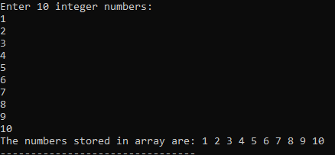

TASK 2:

#include<iostream>

using namespace std;

int main(){

int array[5];

int sum=0, product=1;

cout<<"Enter 5 integer values: "<<endl;

for(int i=0;i<5;i++){

cin>>array[i];

}

for(int i=0;i<5;i++){

sum=sum+array[i];

product=product*array[i];

}

cout<<"The sum of all elements of array is: "<<sum<<endl;

cout<<"The product of all elements of array is: "<<product<<endl;

return 0;

}

OUTPUT:

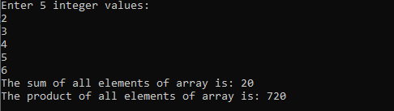

TASK 3:

#include <iostream>

using namespace std;

int main(){

int row;

cout<<"Enter the length of the longest row in the diamond"<<endl;

cin>>row;

if(row%2==0){

row++;

}

int h=(row+1)/2;

const int size=row;

char arr[size];

for(int i=0;i<size;++i){

arr[i]='*';

}

for(int i=0;i<h;++i){

for(int j=0;j<h-i-1;++j){

cout<<' ';

}

for(int k=0;k<2*i+1;++k){

cout<<arr[k];

}

cout<<endl;

}

for(int i=0;i<size;++i){

arr[i]='*';

}

for(int i=h-2;i>=0;--i){

for(int j=0;j<h-i-1;++j){

cout<<' ';

}

for(int k=0;k<2*(i+1)-1;++k){

cout<<arr[k];

}

cout<<endl;

}

return 0;

}

OUTPUT:

